Resume Format Research
As part of this task, I researched the different types of resume layouts commonly used today, in order to understand which formats are easiest for a parser to process correctly and which ones are more likely to cause issues. I collected a real example of each layout type and analyzed how each one would behave when processed by a program that extracts text, rather than evaluating them purely on visual appearance.
The 6 Layouts I Looked At 1. Single-column resumes
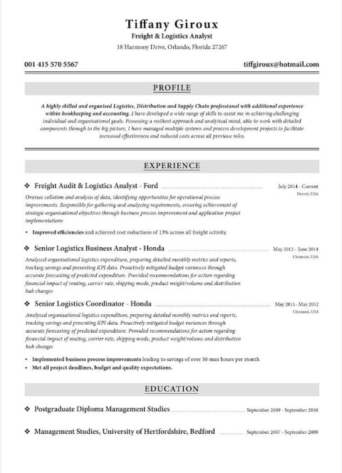
In this layout, all content runs top to bottom in a single column: name and contact details at the top, followed by sections such as Summary, Experience, and Education. Because there is only one column, the text is extracted in the same order a person would naturally read it, which makes this format straightforward for a parser to process
- Two-column resumes
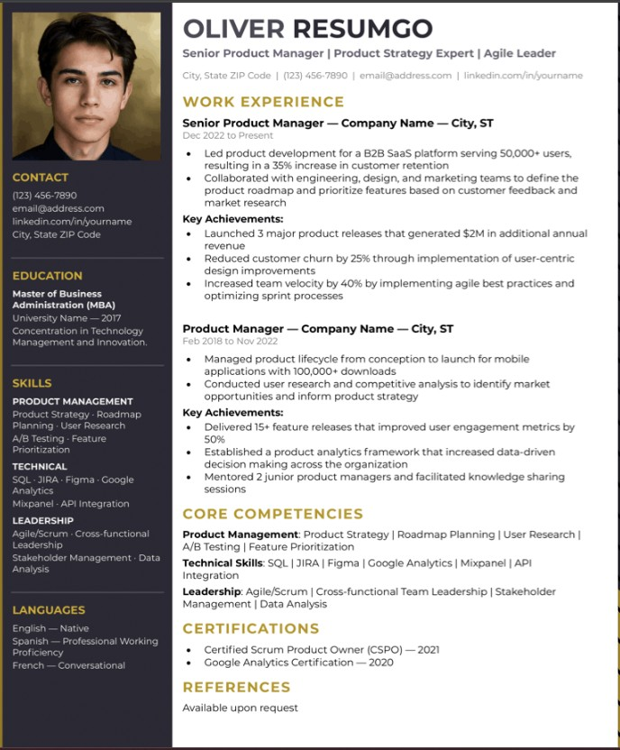
This layout uses a sidebar (typically on the left) for information such as Contact, Education, and Skills, with a main column containing Experience and Core Competencies. While this looks well-organized to a human reader, a PDF does not actually recognize the concept of columns — it only knows where text is positioned on the page. As a result, a parser often reads across the page line by line rather than down one column and then the other, which can mix content from both columns together.
- Modern / creative templates
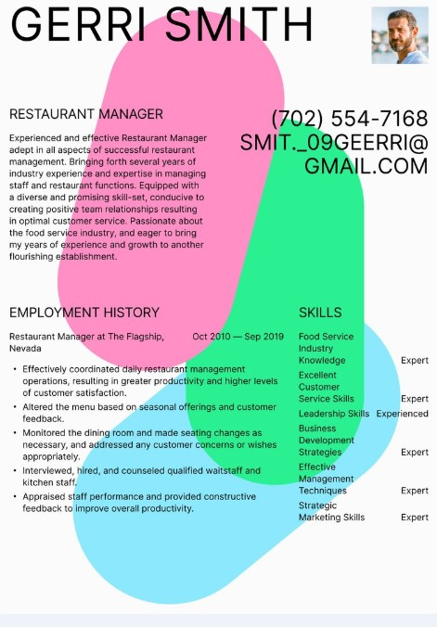
These resumes use graphic elements such as bold shapes, oversized text, and photos — the example collected here places text directly over colored decorative shapes. While visually engaging, this kind of layout can cause text to extract in a broken or unpredictable order, and many of the visual design elements do not translate into readable text at all.
- ATS-friendly templates
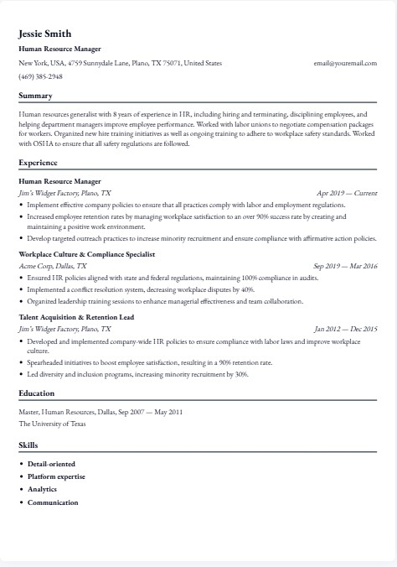
These templates are intentionally designed to be simple: a single column, plain text, standard fonts, and clear section headings such as Summary, Experience, Education, and Skills, with no tables or graphics. This makes them the easiest case for a parser to handle, which is why career centers commonly recommend this format for job applications.
- Image-based resumes
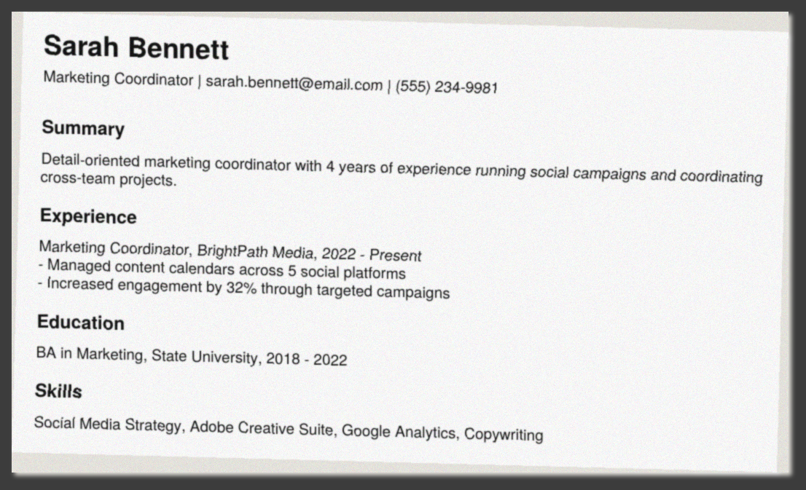
For this example, I created a standard resume and then flattened it into a plain image file rather than a text-based PDF. Visually, it appears identical to a normal resume, but there is no selectable text behind it — only pixels. A library such as pdfplumber would extract no text at all from a file like this. This represents what a scanned paper resume or a photo of a resume would produce, and would require OCR (optical character recognition) to process, which is a different approach from the one used in this project so far.
- Multi-page resumes
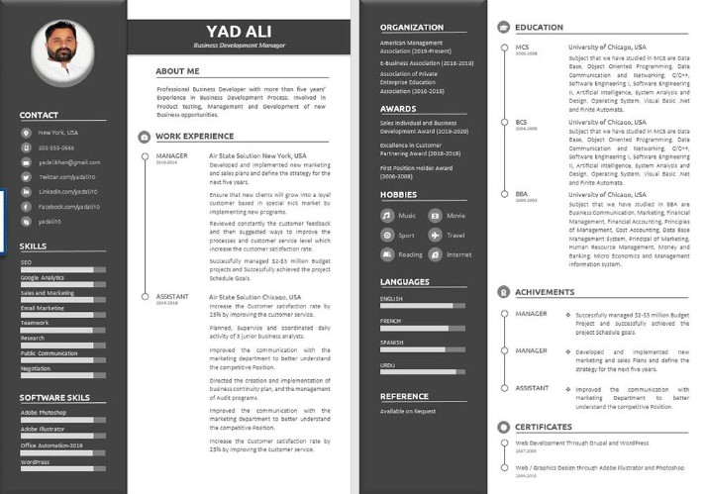
These are longer resumes that extend across two or more pages, typically used by candidates with more extensive experience. This format is not necessarily more difficult to parse, since the text itself extracts the same way — however, the parser must be able to process every page rather than stopping after the first, and needs to account for a section that may be split across a page break.
Which Ones Are Easiest vs Hardest to Parse
Layout | Difficulty | Why
ATS-friendly template | Easiest | Built specifically to be simple and predictable
Single-column resume | Easy | Reads top to bottom, same order a person reads it
Multi-page resume | Easy-Medium | Just needs to loop through every page correctly
Two-column resume | Hard | Text from both columns can get mixed together
Modern/creative template | Hard | Graphics, shapes, and odd text placement confuse extraction
Image-based resume | Hardest | There's no real text at all — just a picture
Why Some Resumes Fail in ATS Systems
ATS stands for Applicant Tracking System — the software companies use to automatically scan resumes before a human reviewer sees them, which operates on the same basic principle as the parser developed in this project. Based on my research, resumes typically fail or get misread in ATS systems for the following reasons:
- Columns and tables — the ATS reads left-to-right across the page, which can cause it to interleave text from a sidebar with a sentence from the main column.
- Headers/footers — some ATS software skips these sections entirely, so contact information placed in a header can be missed completely.
- Images and graphics — a photo, icon, or a skill represented as a graphic bar is not read as actual text.
- Unusual fonts or text boxes — decorative fonts or text inside floating design elements can be extracted as garbled characters or skipped altogether.
- Non-standard section names — an ATS looks for expected headings such as 'Experience'; a creative heading like 'My Journey' may not be recognized as the Experience section at all.
Conclusion
Overall, the simpler and more standardized a resume's layout is, the easier it is for a program to read correctly. This is because parsers and ATS systems fundamentally read text in the order it is positioned on the page, rather than interpreting the visual design. This conclusion is also supported by my earlier testing: a standard single-column resume extracted very cleanly using the Python libraries evaluated in this project, whereas a two-column or image-based resume would be expected to introduce significantly more errors. This is an important consideration going forward, since the parser should not assume every resume will extract as cleanly as the test sample used in earlier testing.

Examples:
1. Single-column resumes
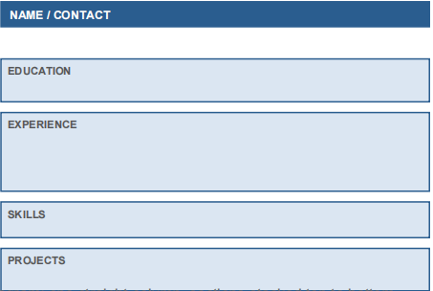
- Two-column resumes
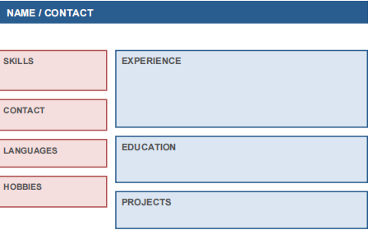
- Modern / creative templates
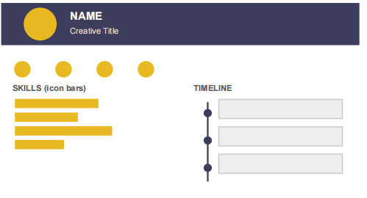

- ATS-friendly templates
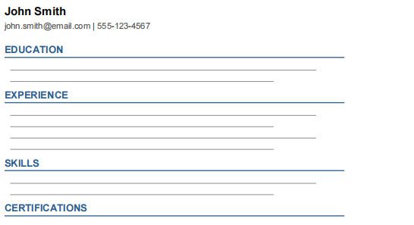
- Image-based resumes
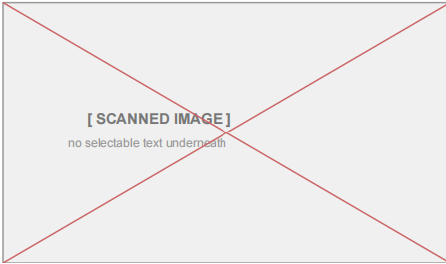
6. Multi-page resumes
